Module eight
Conjunctions
A conjunction is a word used to connect clauses or sentences or to coordinate words in the same clause. The most popular conjunctions are and, but, or, if, while, although, etc. The conjunctions are of three types:
- Coordinating conjunctions- A coordinating conjunction is placed between words, phrases, clauses, or sentences of equal rank, e.g. and, but, or.
- Subordinating conjunctions-A subordinating conjunction is that which introduces a subordinating clause, e.g. if, although, because.
- Correlative conjunctions- They get their name from the fact that they work together (co-) and relate one sentence element to another. Correlative conjunctions include pairs such as "both/and," "either/or," "neither/nor," "not/but" and "not only/but also."

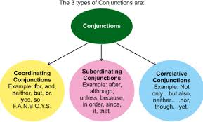

Exercise/Assignment
Frame 10 sentences in which there are at least three conjunctions from each of the types mentioned above (10 marks).

