Module one
Introduction to parts of speech
A part of speech may also be called a word class, lexical class, or lexical category. The terms means that all parts of the speech are named at the word level. Each word of speech has a part and the parts are given certain specific names. Words can be classified according to the positions they occupy in a sentence. A part of speech will then include all words that can occupy identical syntactic positions in a sentence or that can perform identical syntactic functions. There are two distinct categories of parts of speech. The parts of speech may be the closed ones or the open ones. There are some linguists who list only eight parts of speech The present day grammarians list only seven parts of speech. They exclude pronouns and auxiliaries.
The open parts of speech are those to which there is a continuous addition. They are nouns, verbs, adjectives, and adverbs. These four categories continue to grow. The closed parts of speech don’t generally grow. There is number is almost the same. They are pronouns, prepositions, conjunctions, auxiliaries and interjections
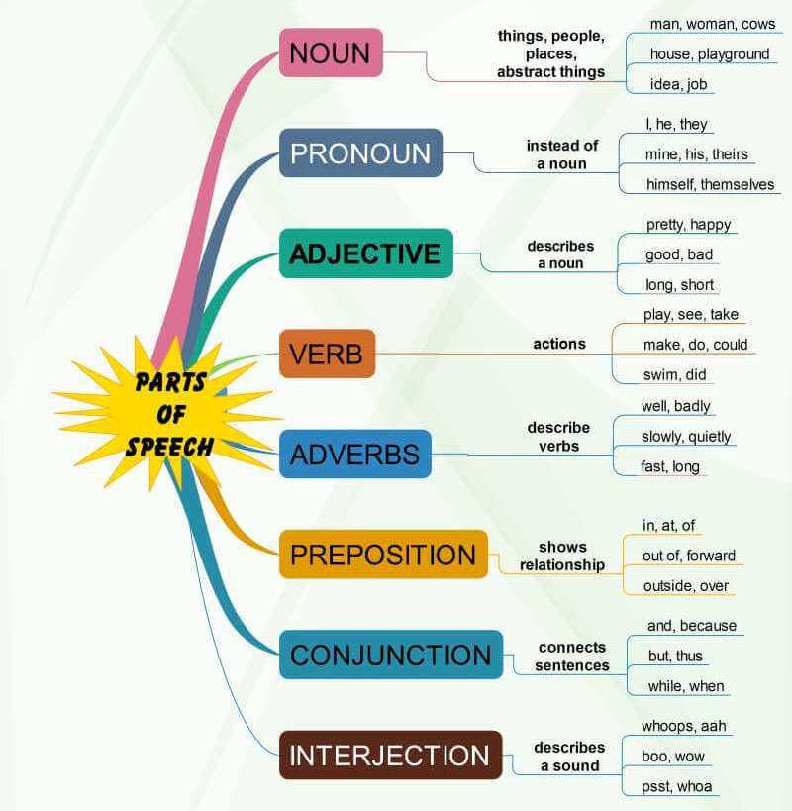

Exercise/Assignment
- Explain in 50 words the concept of parts of speech (5 marks).
- Which parts of speech are open and which are closed (2 marks)?
- Write the three names of parts of speech (3 marks).

