Module nine
Interjections
According to Oxford Online Dictionary, an interjection is “an abrupt remark, especially as an aside or interruption.” An interjection is a word solely designed to convey emotion. It expresses meaning or feeling. An interjection does not grammatically relate to the other parts of the sentence. It only conveys the way the writer is feeling. Interjections are not often used in academic writing. Interjections are sometimes called the exclamatory words. These are used to signify a specific emotion of the author. Interjections can be words which are used to exclaim or protest or command. Many times an interjection is accompanied by a punctuation mark, often an exclamation mark or a comma. They sometimes stand by themselves but at times they are placed before or after a sentence.
The basic kinds of interjections are mentioned below:
- Interjections for pain include- Alas! , Ah! , Oh! , Ouch!
- Interjections for greeting include-Hullo! Hello!, Hi!
- Interjections for joy include- Woo-hoo! Hurrah! , Hurray! , Wow!
- Interjections for doubt include fillers like- Er! Um! Hmmm!

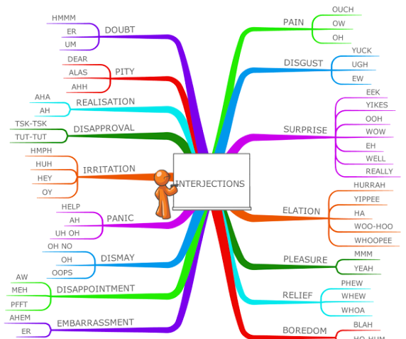

Exercise/Assignment
Make use of any 10 above mentioned interjections in your own sentences (10 marks)

