Module four
Verbs
Verbs are commonly known as action words but they may not always be engaged in action. A verb is an inseparable part of a sentence. These can be used to describe an “action, state or occurrence.” Verbs can be regular or irregular. The regular verbs are those which have the same second (past) and third (past participle) forms. The verb which is an important part of a sentence is called a main verb and the verb which helps the main verb is called a helping verb or an auxiliary. When there are more than one verb in a sentence, that is called a verb phrase. There has to be a main verb in a sentence but helping verb may be there or may not be. Here are some examples of verbs:
I am a boy.(single verb, only main)
They are dancing. (two verbs, one main and one helping verb)
She has been eating since morning. (three verbs, one main and two helping verbs)
There has been a flood. (two verbs, one main and one helping verb)
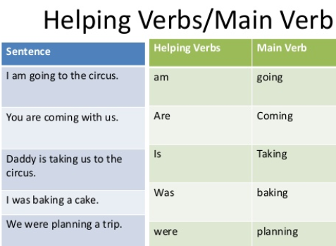

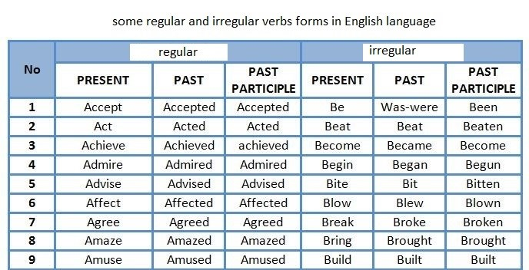

Exercise/Assignment
Choose the main and helping verbs in the following sentences (6 marks):
- She is having some fever.
- They will visit us tomorrow.
- You can help my friends.
Choose the regular and irregular verbs in the following sentences (4 marks):
- I cut the apple with a knife.
- Their friend came to their home yesterday.

