Module two
Nouns
According to Oxford Online Dictionary,” A word (other than a pronoun) used to identify any of a class of people, places, or things (common noun), or to name a particular one of these (proper noun).” In the traditional definition, a noun "refers to a person, place, or thing." But as has often been pointed out, this definition incorrectly excludes nouns like the following:

(1) blast, glint, mind, storm, value
Consequently, present grammarians define nouns not in semantic (meaning-based) terms, but in distributional terms---with reference to their occurrence relative to other syntactic categories in the language. In English, for instance, a useful criterion for whether a word is a noun is whether it can be accompanied by the determiner the. Accordingly, the words in in (2a) are nouns, but in (2b) are not:

(2) a. the { blast, glint, mind, storm, value }
b. * the { blasted, glinted, minded, stormed, valued }
Nowadays, nouns are divided in two broad categories. These are countable nouns and non-countable nouns:
In English grammar, countable nouns are individual people, animals, places, things, or ideas which can be counted. Uncountable nouns are not individual objects, so they cannot be counted.
Here are some examples:
Countable nouns:
There are at least twenty five Indian blocks in Cuzan.
Megh took a lot of photographs when he went to the Grand Canyon.
Non-countable nouns:
There is not much water in the mug.
Let’s get rid of that garbage.
Some nouns can behave both as countable and non-countable nouns:
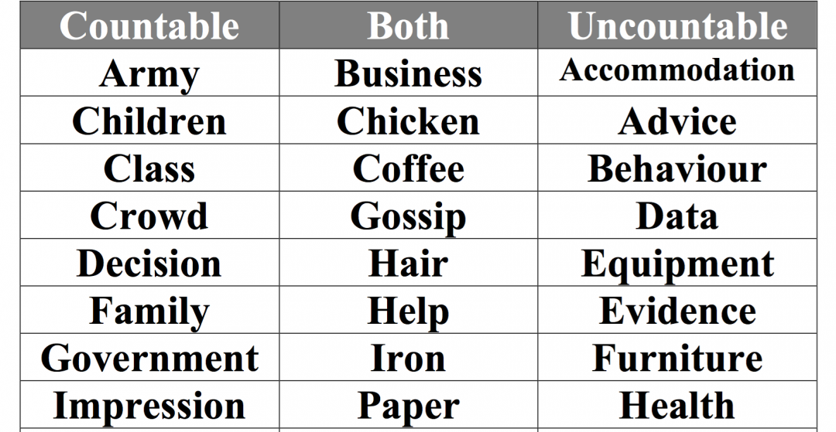
Exercise/Assignment
Separate the countable and non-countable nouns from the following (10 marks):
Book, furniture, boy, equipment, homework, failure, aircraft, rod, ice, fun.

