Module five
Adjectives are those words which qualify or modify nouns and pronouns. Cambridge Online Dictionary defines an adjective as, “word that describes a noun or pronoun.” The following are some examples of adjectives:
- She is a naughty girl.
- My uncle is old.
- They are cheats.
Sometimes there are different forms of the same adjective. If one clown makes a person laugh more than another clown, then that clown is funnier. This is called the comparative form. The drink that is colder than any other drink is the coldest drink. This is the superlative form of "cold". Some adjectives need additional words during comparisons. For instance, a bike may be cheaper than another, but the second car may be more reliable (we use "more reliable", instead of "reliabler"). Reliable means worthy of trust.
Generally, for short adjectives (single syllable) ending in a consonant like "cold," "black," or "fast," one adds the suffix er to make a comparison of greater magnitude. Example: "The North Pole is colder than Florida." The greatest possible comparison is made by adding the suffix est. Example: "The North Pole is the coldest place on the Earth." For long adjectives (more than one syllable) like intelligent, conscientious, comprehensive, one uses the word more to make a comparison of greater magnitude. Example: "Children are more intelligent than adults."
A superlative makes the greatest possible comparison. One uses the word most. Example: "She is the most religious person I have ever come across."
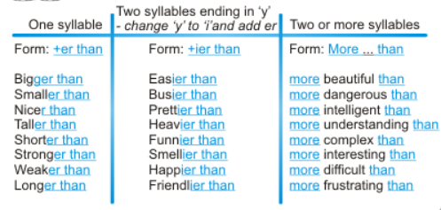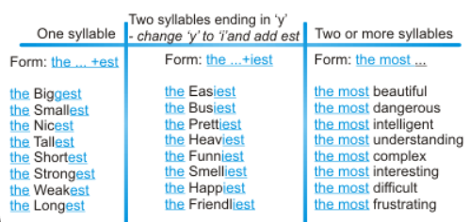
Exercise/Assignment
Change the following adjectives into their comparative and superlative forms (10marks):
young, old, intelligent, interesting, remarkable

