Module three
Pronouns
According to the Longman Online Dictionary, “a word that is used instead of a noun or noun phrase, such as ‘he’ instead of ‘Peter’ or ‘the man’.” English language has a very limited and definite set of pronouns.
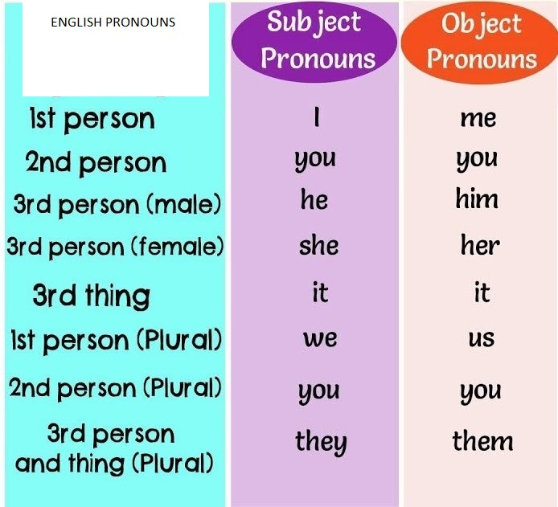
The first person refers to “me” and the second person refers to “who is being addressed to” and the third person is someone who is neither “me” nor “you”. These can be singular or plural. They can be used as “subject” or “object”. Subject is the doer and object is the one on whom action takes place.
Exercise/Assignment
Use proper nouns in the following blanks (5 marks):
- Sue’s mother drove ________to school.
- My father looks smart. I really admire______.
- Some boys hit me last night. _______were caught by police today.
- ______is my book.
- ____is the worst among all the gentleman.

